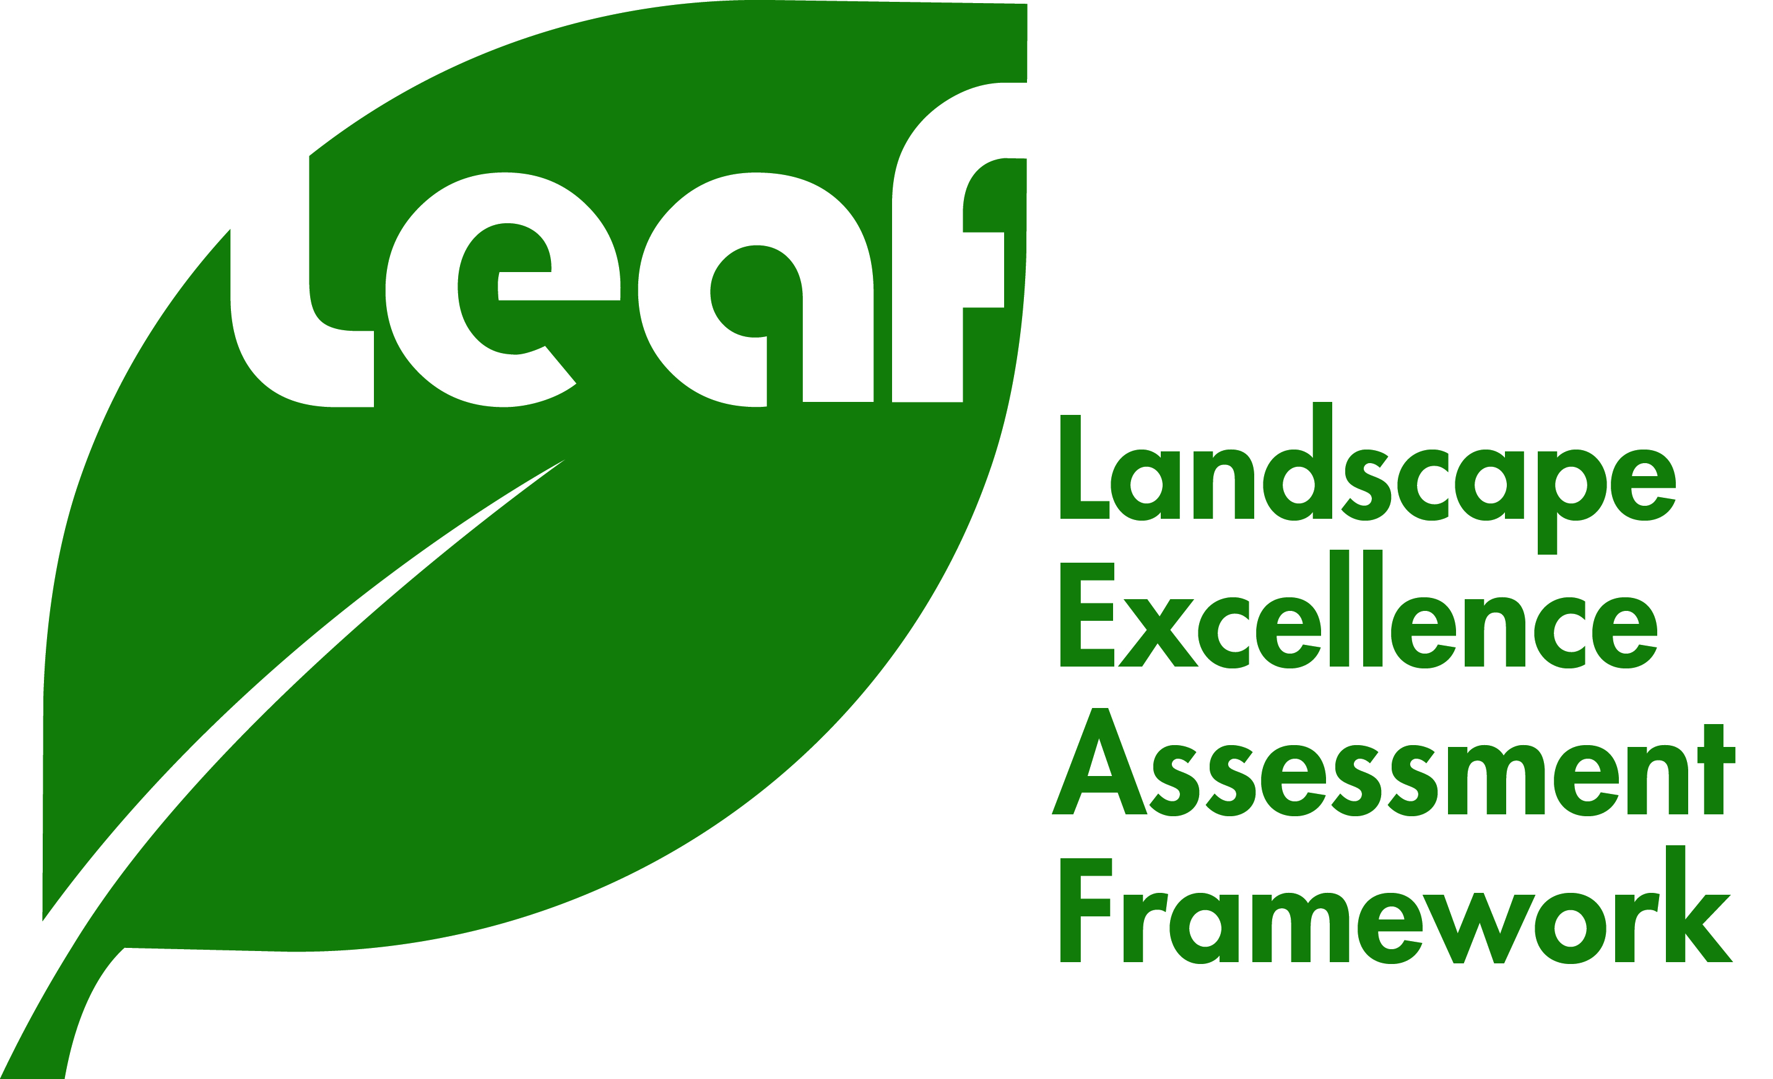
LANDSCAPE EXCELLENCE ASSESSMENT FRAMEWORK

Instructions for application of LEAF certification:

- Complete the application form.
- Submit the completed forms with the supporting documents to NParks_LEAF@nparks.gov.sg
- Upon successful acceptance of application, both applicants and LEAF assessors will convene for an assessment meeting. (For existing developments: Applicants need to arrange for a site visit of the development.)
- Applicants will be notified of the results after the completion of assessment.
Upon successful certification of the development, the applicant will be requested to prepare the following:

- High-resolution photographs or images (300dpi) of the development and its greenery features, with captions
- 200-word write up on the development’s outstanding features
- Media Factsheet (template will be provided)

Alternative arrangements for submission of documents:

- Download link – Upload your documents and send us the link to download your documents to NParks_LEAF@nparks.gov.sg
- Courier services – Please send your documents (softcopy only) to:

Attn: LEAF Secretariat
CUGE House 1
1G Cluny Road, Singapore 259603

For any further enquiries, please email us at NParks_LEAF@nparks.gov.sg

Thank you.

Landscape Excellence Assessment Framework
Application Form

- PROJECT INFORMATION

Development Name / Project Title
- Name of development indicated here will be used for all official purposes. Please check the name for accuracy.
Address of Development
Postal Code ( )

Development Type
- Residential | - Commercial | - Educational Institute |  | - Public Infrastructure
- Others: ____________________________

Type of Development |  |  | New/Existing
Completion Date |  |  | DD/MM/YYYY
DC Project Reference
Gross Floor Area
Total Green Area(Sq M)
No. Tree / shrub species
Green Plot Ratio
% Native Plants

- DEVELOPMENT OWNER’S PARTICULARS

Name of Firm / Company:
Contact Person: |  | Designation:
Mailing Address (if different from above)
Postal Code ( )

Contact No.: |  | Facsimile No.:
Email:

Declaration
I hereby grant permission to the below personnel(s) to submit the development listed above for LEAF Certification.

Name of Development Owner / Representative
Signature of Development Owner
Date

- PROJECT TEAM MEMBERS
- Please indicate the team members/companies in the table below, 1 representative per company.
- Please ensure that the companies’ names are checked for accuracy.
- Team Leader will be the main contact person for this application.

Team Member 1 (Team Leader)
Name of Company:
Role in Project:
Contact Person:
Address:
Contact No.:
Facsimile No.:
Email:
Team Member 2
Name of Company:
Role in Project:
Contact Person:
Email:
Team Member 3
Name of Company:
Role in Project:
Contact Person:
Email:
Team Member 4
Name of Company:
Role in Project:
Contact Person:
Email:
*Please expand the table with more rows for any addition of team members.

- NARRATIVE DESCRIPTION
- Please provide a brief description of your project, highlighting the main features of the landscaping for have a brief understanding of the development.
- The description may be used for LEAF official purposes and publications.
- no more than 300 words

- CHECKLIST OF DOCUMENTS TO BE ENCLOSED WITH APPLICATION
- Completed with self-evaluation form
- Project Brochure (if available e.g. sales brochure)
- Copy of DC, BP and other relevant planning approvals (for new projects, DC approval is required)
- Lay-out plans of existing or proposed development
- Landscaping plan
- Topographical plan of existing site (for new projects)

- AWARD CONDITIONS

- All LEAF Certification applicants are required to meet the requirements of the various planning and regulatory authorities, including those of NParks.
- For New Developments receiving LEAF Certifications, the awards can be withdrawn if NParks/CUGE deems the completed developments have significantly deviated from the proposals reflected in the application.
- The owners and copyright holders of the drawings, photographs, slides and all graphic materials, submitted to the National Parks Board, in connection to the LEAF certification, hereby grant NParks the right to publish, display, exhibit, reproduce or otherwise publicise or communicate all entries submitted, subjected to appropriate citation and acknowledgement of the authors without putting the organiser under any obligation whatsoever. Such right shall be exercisable by NParks without any payment, charge or fee whatsoever to any person.
- Individual or firm submitting projects for LEAF Certification can only include drawings, photographs, slides, plans, graphics and written materials it has the copyright. If the entrant does not own the copyright then they must secure permission from all copyright holders and or owners of the material. Each entrant certifies that permission has been obtained from the owner of the project to publish the photographs and information submitted.
- NParks is hereby given permission to make any editorial changes and/or additions to the materials submitted in this entry as they may deem necessary or desirable for publication or display purposes. Neither the use of the copyrighted materials nor the permission granted hereby infringes upon the ownership, copyright, trademark or rights of the others.

- DECLARATION
I hereby agree to abide by these conditions, rules and regulations and certify that all information that I have submitted is correct and true. I declare I am the author of the submitted project.
Name of Team Leader
Signature of Team Leader
Date

